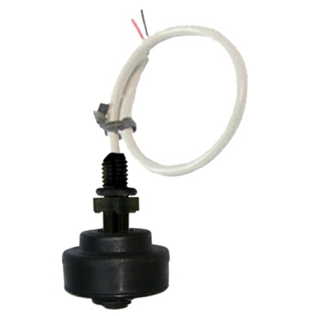

**Type DM**

**Vertical mounting, reed switch contact, polypropylene stem with M8 thread, dia. 29 x 16.4mm hollow polypropylene float, cable output, for near bottom level detection.**

Use: low voltage circuits.

Main applications: steam generators, coffee machines, vending machines, air conditioning pumps, dehumidifiers.

Float material: hollow polypropylene.

Contact configuration: normally closed when float is down on the stem. It opens when float goes up to the wiring side. Upsetting the float changes the contact configuration into normally open.

Electrical rating:

Low voltage type: maximum power 10 W (VA), max 0.5Amp, max voltage 110VAC.

230VAC type: max power 40 W (VA), max 1Amp.